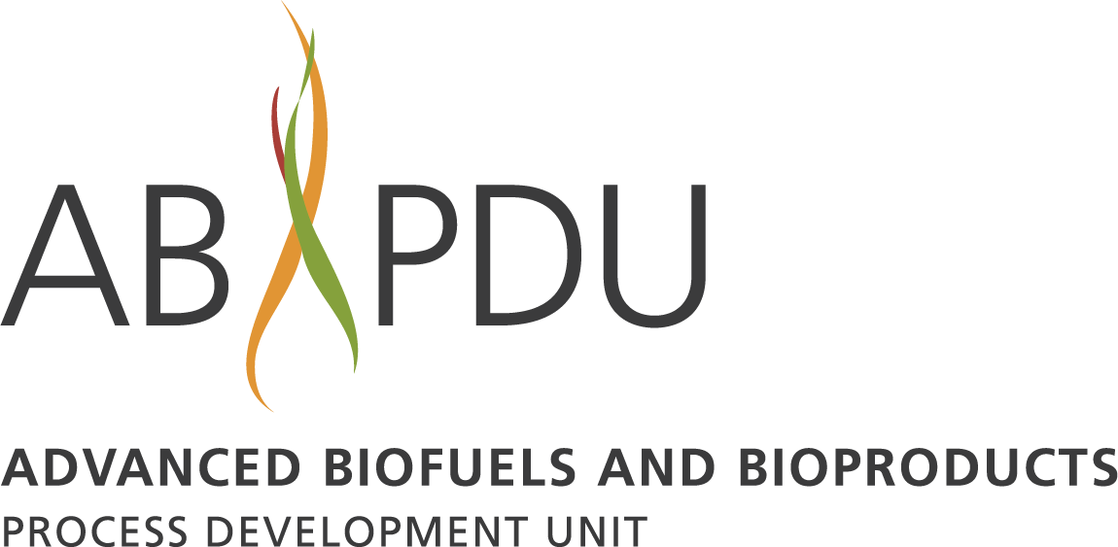

ABPDU Industry Listening Day
Monday, Oct. 28th, 2019
5885 Hollis St., Emeryville, CA

Agenda

1:00 - 1:20 Introductions

1:20 - 1:40 Introduction to BETO and ADO Introduction
Mark Shmorhun, BETO Technology Manager

1:40 - 2:00 Introduction to ABPDU
Deepti Tanjore, Director

2:00 - 2:45 Discussion Topic 1: How can BETO and ABPDU support process R&D?
All attendees

2:45 - 2:55 Report Out

2:55 - 3:05 Break

3:05 - 3:40 Current and Future Infrastructure at the ABPDU
Ning Sun, Scientist - Deconstruction and Waste Conversion
Eric Sundstrom, Scientist - Biological Conversion of Gaseous Feedstocks
Akash Narani, Sr. Process Engineer - Cell-Free Biocatalysis

3:40 - 4:25 Discussion Topic 2: What new equipment/infrastructure should we be
looking at? How can we make it more accessible?
All attendees

4:25 - 4:35 Report Out

4:35 - 5:00 Q&A; Wrap-up

